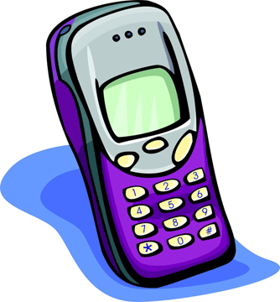
Object Speech
Objective: To promote self-confidence in speech by using an object as a visual aid.

Directions:
- Bring an object to class.
- The object will need to be practical.
- Show the object and completely describe it.
- Tell the uses of the object. These may be practical or humorous or both.
- Tell anything else that pertains to the object that may be of interest to the audience.
- The speech may be either informative or entertaining.
- Time requirement is 1 ½ min.
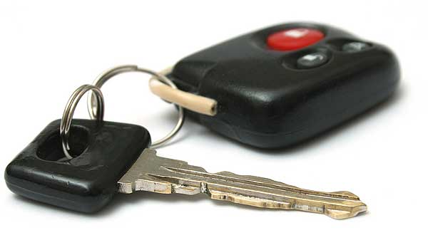
Make sure the attention getter in your introduction and conclusion tie together!
Attention getter ideas: stories, quotes, facts, jokes, etc…
Thesis statement: Today I’m going to tell you about………….

Object Ideas:

- Tennis racket
- Pen
- Gum
- Belt
- Rubber band
- Toothbrush
- Pillow
- Newspaper
- Toilet paper
- Pan
- Pop bottle
- Band-aid
- Piece of paper
- Car keys

