“Chalk Talk” Speech
Objective: To promote self-confidence in speaking by using a visual aid.
- Visual aids are used to help reduce stage fright.
- You will essentially become the teacher.
- So, you will be using the board (or some sort of other technology if you’d like) to illustrate in any way possible the material presented in your speech.
- This type of speech gives you something to do during the speech and provides the audience with something to look at besides the speaker, which I believe is what good speakers do.
- You can be as creative as you want with this type of speech.
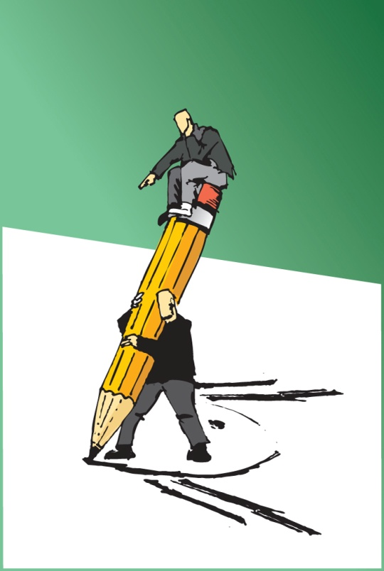
Instructions
- Choose a subject which will lend itself to illustration.
- Prepare a speech outline and drawings to accompany the speech.
- The drawings should help the audience understand the speech subject more clearly.
- Talk about a particular subject while using the board or tablet. Talk and draw, draw and talk.
- This speech is not a test of artistic ability. Simple drawings are best for this assignment.
- The speech may either be informative or entertaining.
- Time limit for this speech is 3 minutes
- The board work may be words, drawings, diagrams, symbols, anything at all which enhances the speech topic. Allow the speech to come to life through the board work.
- Use as much of the board as possible. I suggest working from left to right.
- Be aware of the audience at all times, and be sure not to block the board work.
Topic Suggestions

- Road signs
- Hair styles
- Facial expressions
- Football plays
- Holidays
- Birthday party decorations
- Seasons
- Anything with steps
- Creation

- How to decorate a Christmas tree
- The perfect vacation
- A day at the amusement park
- Choosing a pet
- Teach us something – think of teachers!
- How to get somewhere
- Emoticons
- Directions somewhere
- Operating a computer program
- How to draw…

